

**Bahir Dar University**

**Institute of Technology**

**Faculty of Computing**

**Department of Computer science**

**Object oriented software engineering group project**

**Title: online compliant management system**

Submitted to : Ms. Etsehiwot B.

|  |  |  |
| --- | --- | --- |
| No. | Name |  |
| 1. | Abebe Wondwosen_______1306786 |
| 2. | Yishak Abreham_________1308824 . |
| 3. | Saleamlak Takele________________1308597. |
| 4. | Tadele mesfine_____________1307016. |
| 5. | Animut Alemneh ________________1306126. |
| 6. | Nigist Genene______________1307538. |

**ONLINE STUDENT COMPLAINT MANAGEMENT SYSTEM**

**Use case name**: LOGIN

**Use case number**: UC#1

**Description**: the student logs into the system by entering their name and password

**Actors**: student

**Pre-condition**: the student should be in the database.

**Post-Condition**: the student logged into the system.

**Scenario:**

* Clicks login then enters name, ID number and password.
* Then the system opens its own administrative page then asks the user if they already have an account or want to create a new account.
* If already have an account they are redirected to the complaint portal link.

**Extension**:

* While logging in if the user enters an invalid password the system displays error message and asks the user to try again (to enter the correct password).
* If they don’t already have an account then the system requests the student to create new account.

**Frequency of use**: Every time the user starts a session.

**Priority**: High.

**Use case name**: MANAGE ACCOUNT

**Use case number**: UC#2

**Description**: the student creates an account or updates their account.

**Actors**: student

**Pre-condition**: the student must already have an account.

**Post-Condition**: updated their account in the system.

**Scenario**:

* The student inquires for his profile page to be updated.
* The system views the request then gives the permission to update the account.
* Then the account is updated

**Extension**:

* If invalid or missing information has been entered then the system displays error message and asks the user to enter the correct or missing information.

**Frequency of use**: every time a user wishes to create or update their account

**Priority**: medium

**Use case name**: REGISTER COMPLAIN

**Use case number**: UC#3

**Description**: filing a complaint and sending to the grievance counselor.

**Actors**: student

**Pre-condition**: the student files relevant information about their complaint.

**Post-Condition**: the complaint has been registered and will be sent to the grievance counselor.

**Scenario**:

* The student opens the complaint page.
* The system displays the complaint information page.
* The student fills the necessary info and submits the form.
* Then the system displays the confirmation message.

**Extension**:

* If unnecessary or missing information has been entered then the system displays error message and asks the user to enter missing information.

**Frequency of use**: almost every time

**Priority**: High.

**Use case name**: CHECK PROGRESS

**Use case number**: UC#4

**Description:** the user asks posts their difficult complain to the handling grievance office

**Actors**: student, department head, grievance counselor

**Pre-condition**: the actors must first register their complaint.

**Post-Condition**: user saw their notification page.

**Scenario**:

* The student asks the grievance counselor about his complaint.
* The grievance counselor sends the progress of the complaint
* The system displays the progress of the students.

**Extension**:

**Frequency of use**: almost every time

**Priority**: low

**Use case name**: SEND DECISION

**Use case number**: UC#5

**Description**: those actors submit their complain resolution to their user.

**Actors**: grievance officer, department head, and student.

**Pre-condition**:

* The handling grievance officer logs in first.
* Must check if the department head had sent their solution.

**Post-Condition**: send their resolution to the owner of complaint.

**Scenario**:

* Handling grievance officer opens the home page.
* Checks the solution sent by the department head.
* Sends the solution to the student.
* Click the send button.
* Writes report.

**Extension**:

**Frequency of use**: almost every time.

**Priority**: High.

**Use case name**: SEND FEEDBACK

**Use case number**: UC#6

**Description**: this actor sends feedback to the handling grievance office.

**Actors**: student

**Pre-condition**: the listed actors interact with the home page of the system.

**Post-Condition**: the student sends important feedback to the handling grievance office.

**Scenario**:

* The listed actors open the homepage.
* Click the feedback menu.
* Fill the information on the label.
* Click the send button.

Extension: if there is no feedback the system displays no feedback is posted.

**Frequency of use**: some times.

**Priority**: medium

**Use case name**: view feedback

**Use case number**: UC#7

**Description**: the list actor view feedback sent by users.

**Actors**: handling grievance office, university dean and department head.

**Pre-condition**: the actor should interact with the system.

**Post-Condition**: the actor successfully watches feedback.

Scenario:

* The grievance officer clicks on view feedback icon.
* The system displays the student’s feedback.

**Extension**: the actor may replay feedback.

**Frequency of use**:

**Priority**: High.

**Use case name**: MAINTAINANCE

**Use case number**: UC#8

**Description:** maintenance of the system

**Actors**: System Administrator

**Pre-condition**: must qualify to be the admin.

**Post-Condition**: the system is always being administered.

**Scenario**:

* The administrator checks the overall workings of the system.
* Maintains the integrity of the system.
* Controls complain and feedback profanity.
* Upgrades the software when it’s out of date.

**Extension**:

**Frequency of use**: Every time

**Priority**: High.

***The use case diagram***

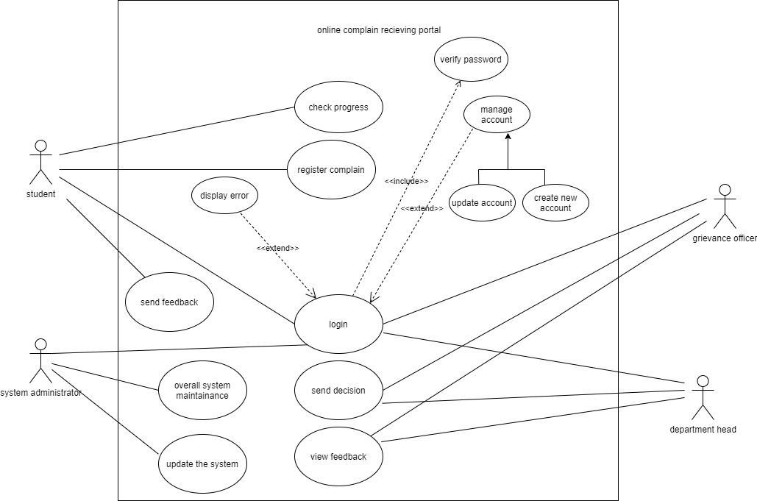

***THE CLASS DIAGRAM***

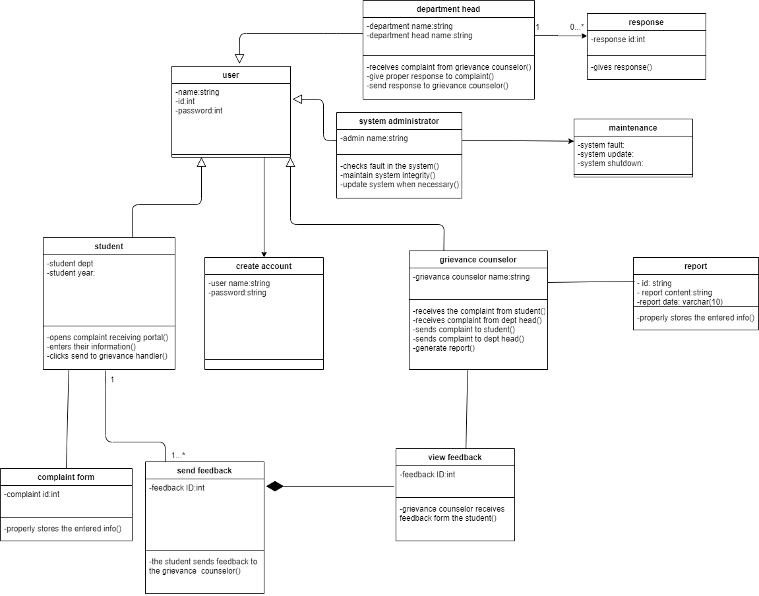

***THE SEQUENCE DIAGRAMS***

LOGIN SEQUENCE DIAGRAM

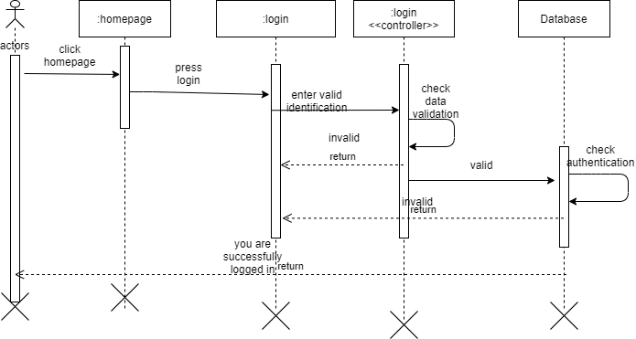

COMPLAINT REGISTRATION SEQUENCE DIAGRAM

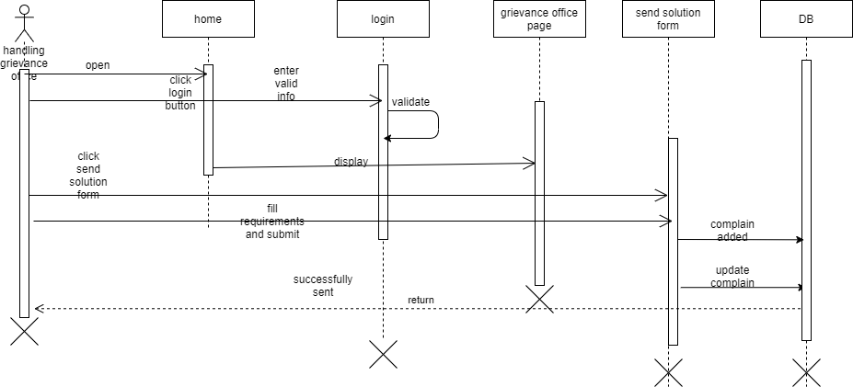

SEND COMPLAINT SEQUENCE DIAGRAM

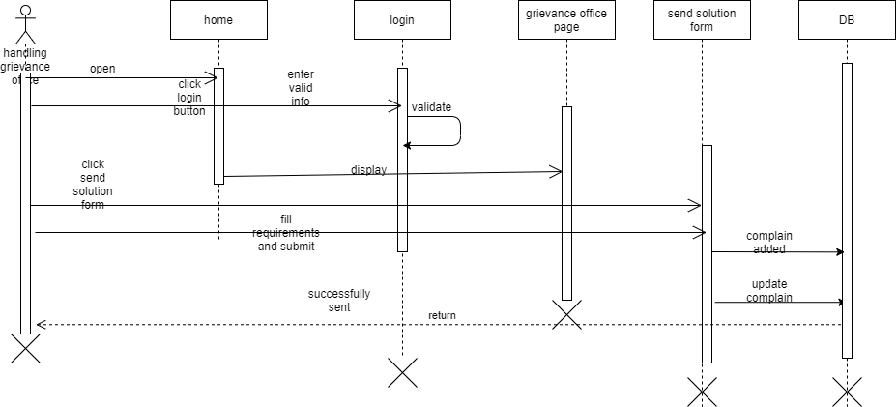

VIEW COMPLAINAT SEQUENCE DIAGRAM

